|  |  |  |
| --- | --- | --- |
| f |  |  |
| **Benha University** |  | **Faculty of Computers & Artificial Intelligence** |

**Digital clock**

**In**

Logic design

**by**

Student’s Full Name (Student Section Number)

|  |  |
| --- | --- |
| عبدالرحمن محمد احمد احمد | Section 11 |
| عبدالرحمن عباس محمد عباس | Section 11 |
| عبد الحليم مصطفى محمد شبانه | Section 11 |
| عبدالرحمن حمدي حسن علي | Section 11 |
| ندي عبدالفتاح صلاح الدين | Section 21 |
| نعمه ناصر مرزوق | Section 21 |

**Supervised by**

ENG/Mayada

Table of Contents

1. Introduction 1

2. Content 2

*2.1* *Apparatus* 2

*2.2* *555Timer* 3

*2.3* *equation* **Error! Bookmark not defined.**

*2.4* *4026 counter* 4

*2.5* *counter of seconds* 5

*2.6* *counter of minutes* 6

*2.7* *counter of hours* 7

*2.8* *7 segment* 7

*2.9* *3-input AND gate* 8

3. Table of units and measurements 8

**4. Conclusion……………………………………………………………………………………………………………………9**

# Introduction

Counting and keeping track of numbers are a few of the fundamental aspects we need to do regularly. Previously, people used to follow some orthodox procedure to do the calculation. Over time, due to the advancement of modern science and technology, we came up with better and more efficient methods for doing so. Now, different automated processes to do counting have been developed. Right after the industrial revolution, mechanical counters had been integrated with machines. Thus, from the 20th century and onward, counters and timers have been implemented with electronics.

A common example of a counter application in timekeeping systems is shown in this figure implified logic circuit of a digtal clock that displays seconds, minutes and hours.

First a 555 astable timer converts AC voltage to a 1 HZ pulse waveform followed by a divide by 10 counter, followed by a divide by 6 counter, which form both of the seconds counters , followed by a divide by 10 counter, followed by a divide by 6 counter which forms both of the minutes counters, and later on the pulse waveform is followed by a divide by 10 counter and a divide by 2 counter making the the hours counters.

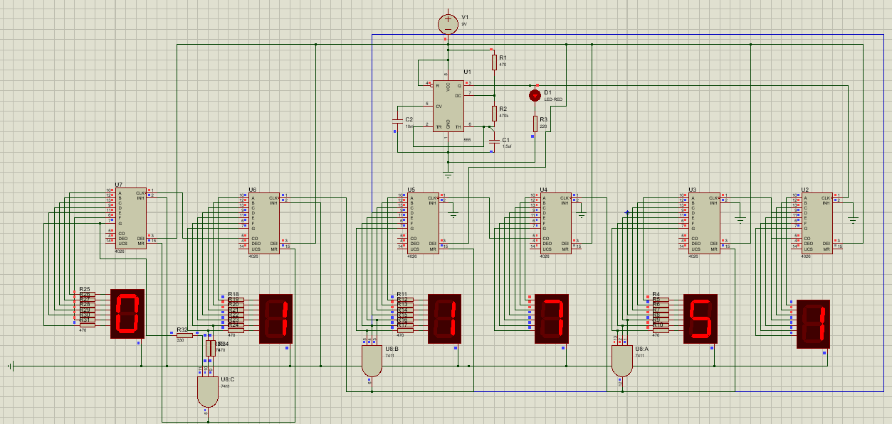Both of the seconds and minutes counter count from 0 to 59 then recycles to 0, Sending a pulse to the upcoming counter to increment by 1, and the hours counter reset on 24.

Figure 1.1

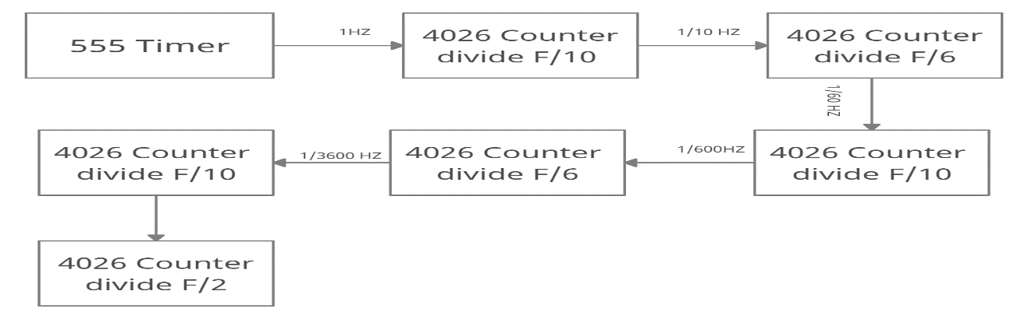

Figure 1.2

**The 4 blocks of a digital clock are:**

* By using 555 timer 1 Hz clock generator to generate 1 PPS (pulse per second) signal to the seconds block.
* SECONDS block - contains a divide by 10 circuit followed by a divide by 6 circuit. Will generate a 1 PPM (pulse per minute) signal to the minutes block. The BCD outputs connect to the seven segement curcuits to display the seconds values.
* MINUTES block - identical to the seconds block it contains 2 dividers; a divide by 10 followed by a divide by 6. Will generate a 1 PPH (pulse per hour) signal to the HOURS block. The BCD outputs connects to the BCD to Seven Segment circuit to display the minutes values.
* HOURS block - it is 24H clock, will have a divide 24. For 24H, it will count from 00 to 23. The BCD outputs connects to the BCD to Seven Segment circuit to display the hours values.

## *Content*

### ***2.1 Apparatus***

* 555 Timer
* VCC 9 V
* Resistors
* Capacitors
* 4026 Decade Counter
* 7 Segment Common Cathode
* 3-Input AND Logic Gate

#### **2.2 555 Timer**

Astable timer is a device that has no stables the resulting output typically square wave that is used as a clock singal in many types of sequential logic curicuts .When a 555 timer is operating in Astable mode we obtain a pulse on the output pin whose ON time (Time high) and OFF time (Time low) can be controlled. This controlling can be done by selecting the appropriate values for the Resistor R1,R2 and capacitor C1. circuit can be used to produce a square wave in which the high time (T1) and low time (T2) can be calculated. This method used to generate clock pulses for Digital IC’s or blink an LED . The output wave obtained from (OUT)-(pin3)

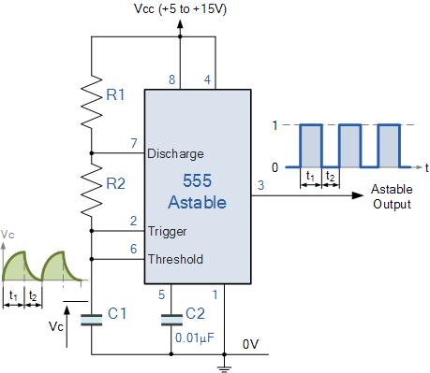

Figure 2.1

As shown in this figure , 555 timer pulse frequency could be manipulated using the value of components R1,R2 and C1.

**2.3 Equations**

The equation of 555 timer is

|  |  |  |
| --- | --- | --- |
| **Parameter** | **Formulae** | **Unit** |
| Time High (T1) | 0.693 × (R1+R2) × C1 | Seconds |
| Time Low (T2) | 0.693 × R2 × C1 | Seconds |
| Time Period (T) | 0.693 × (R1+2×R2) × C1 | Seconds |
| Frequency (F) | 1.44 / (R1+2×R2) × C1 | Hertz (Hz) |
| Duty Cycle | (T1/T)×100 | Percentage (%) |

$$f=\frac{1}{T}=\frac{1.44}{\left(R1+2R2\right)*C1}$$

$$f=\frac{1}{T}=\frac{1.44}{\left(470+2*470*{10}^{3}\right)*{1.5*10}^{-6}}$$

##### ***2.44026 Counter***

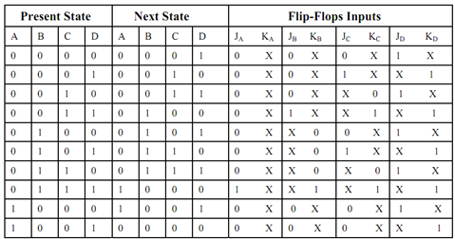4026 counter is an integerated circuit that is made of a 4 bit decade counter that counts from 0 to 9 and recycles at 9 going into a decoder that decode the binary BCD output to a 7 segment.

Figure 3.1

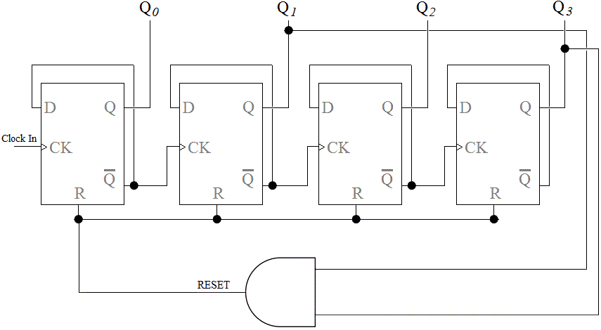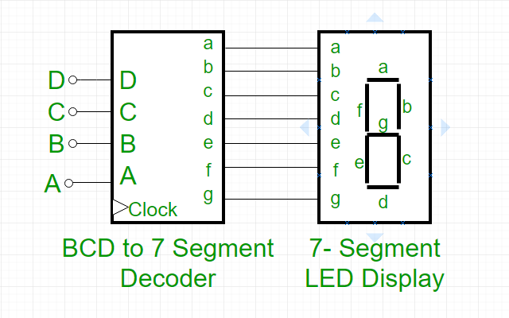

Figure 3.2 Figure 3.2

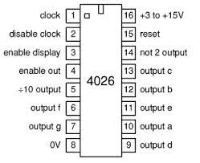x**Truth table :**

|  |  |
| --- | --- |
| **Count** | **BCD** |
| **0 (start)** | **0000** |
| **1** | **0001** |
| **2** | **0010** |
| **3** | **0011** |
| **4** | **0100** |
| **5** | **0101** |
| **6** | **0110** |
| **7** | **0111** |
| **8** | **1000** |
| **9** | **1001** |
| **10(reset)** | **0000** |

Figure 3.4

###### ***2.5 Counter of Seconds***

Counter of seconds is divided into two 4026 counters a single counter and a tens counter.The single counter works on the 555 timer directly so it increment by 1 with every pulse that comes out of the 555 timer output so it counts from 0 to 9 and then recycles.

The tens counter clock input is connected to the 5 pin of the previous counter so the tens counter is incremented by 1 every full circle the single counter does

The tens counter needs to stop at 6 and recycles so it can counts one minute every time

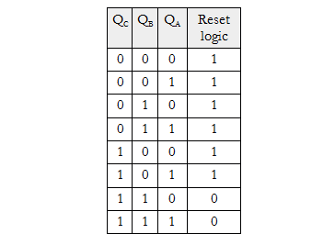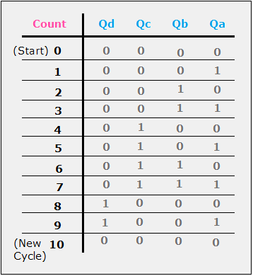If we look at the next figure we will notice that first time the e, f, and g output are all on at the same time is when the output is 6, so the best solution is to connect the e, f, and g outputs to a 3-Input AND gate whose output is connected to the reset of the tens counter and to the clock of the next counter so the minutes is incremented by 1

Both of the counter are connected to a 7 Segment common cathode to display its output.

Figure 3.5

**2.6 Counter of minutes**

Counter of minutes is based on the same idea as the counter of seconds Counter of minutes is divided into two 4026 counters a single counter and a tens counter.

The single counter works on the output of the And gate which is sends a pulse everytime the seconds counter reach 60 seconds.

The single counter counts from 0 to 9 then recycles and its output which is divided by 10 is sent as the clock of the tens counter.

The tens counter is incremented by 1 everytime the single counter finishes a cycle and then recycles when it reaches 6 as the e, f, and g output is connected to a 3-input AND gate which is connected to the counter reset input.

Both of the counter are connected to a 7 Segment common cathode to display its output.

***2.7 Counter of Hours***

Counter of hours is divided into two counter one calculate the single and one calculate the tens

The first counter counts from 0 to 9 normally and its clock is coming from the minutes AND gate so whenever the minutes reach 60 a pulse is sent to the single hours counter.

|  |  |  |
| --- | --- | --- |
| Count | Q0 | Q1 |
| **Count** | **Q0** | **Q1** |
| **0** | **0** | **0** |
| **1** | **0** | **1** |
| **2** | **1** | **0** |
| **3 (recycles)** | **0** | **0** |

The tens hours counter takes its clock from the single counter which means that whenever the single counter finishes a cycle a pulse is sent to increment the tens counter by 1.

Both the single and the tens counters need to stop at 24 so both of the counter needs to reset at the same time when the singles reach 4 and the tens reach 2.

If we look at figure 3.5 we will see that the outputs f, and g are both on for the first time at 4, and g is on for the first time at 2.

So if we connect the f, and g outputs from the single counter with the g output from the tens counter in a 3-input AND gate and connected its output to the reset input of both of the counter the clock would reset at 24

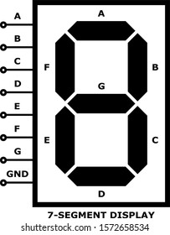**2.8 7 Segments**

7 Segments are used to display the output of the counters and the type that is used here is common cathode 7 segments because the 4026 output is active high.

**2.9 3-Input AND gate:**

|  |  |  |  |
| --- | --- | --- | --- |
| C | B | A | OUTPUT |
| 0 | 0 | 0 | 0 |
| 0 | 0 | 1 | 0 |
| 0 | 1 | 0 | 0 |
| 0 | 1 | 1 | 0 |
| 1 | 0 | 0 | 0 |
| 1 | 0 | 1 | 0 |
| 1 | 1 | 0 | 0 |
| 1 | 1 | 1 | 1 |

**Table of units and measuremeants**

|  |  |  |
| --- | --- | --- |
| Name | Symbol | Value in SI unit |
| Voltage | V | 1V |
| Ohm | Ω | 1 Ω |
| Kelo Ohm | k Ω | 1000 Ω |
| Farad | *F* | *1F* |
| Micro Farad | Uf | 1 ${10}^{-6}$* |
| Nano Farad | nF | 1 ${10}^{-9}$* |

**Conclusion**

The importance and application of these precision instruments are enormous in every work-field and our daily life. The output that is displayed on the digital screen makes it very much easy to make a variety of entries.

Also, these devices are very economical, easy to operate and can be used for various purposes. Grab these when you are struggling with your time management and you never know how much you will be able to get done with, once you get started!

There are varieties of timers and counters in the market. Differences mostly lie in the functionalities of the devices. So, get yourself the one that fits your purpose and go through the manual to use it effectively.